# **Subway**

# **Project Proposal**



**Supervisor**

Ma’am Zara

**Submitted by**

Muhammad Farjad

{2021-SE-56}

Muhammad Salman

{2021-SE-04}

**Department of Computer Science,**

University of Engineering and Technology, Lahore, New-Campus.

[24-APRIL-202]

# Contents

**Project Title** 1

1

**Project Proposal** 1

Contents 2

**Abstract** 3

**Introduction** 3

**Problem Statement** 3

**Objectives** 3

**Requirements (Functional and Non-Functional)** 3

**Related Work** 4

**Proposed Methodology/System** 4

**Wirframes** 4

**Timeline/Gantt chart** 5

**References** 5

# **Abstract**

Subway[1] is a fast-food chain restaurant whose franchise is all around the world. Subway have become second largest sandwiches seller in the world. Subway[ref] has nearly 40,000 restaurants, all independently owned and operated by franchise[ref].

The Objective of Subway[ref] is to provide variety of sandwiches and nonrental diet instead of pizza and hamburgers as they cause problems. There main focus is to provide low calories meals with good taste. The Main goal is to provide customize food that meets the customer taste and needs.

In upcoming years, Subway[ref] will add further more franchises and variety of nutritional diet for all kinds according to the need of the regular customers. By this Customer can enjoy their taste without tension of any problem.

**Introduction**

Subway[ref] is a US[ref] incorporated organization that operates in the fast-food industry. Mainly concentrating on sea sandwiches, the company expands through the area monopoly strategy. Doctor’s Associate Inc. not only owns the fast-food supply chain, but also operate it(ref).

Subway[ref] is one of the first growing single brands across the globe. As at the end of 2014, the organization had an excess of 43,000 different outlets in over 108 operational territories (Convert & Gibson 2015[ref]).

Subway[ref] provides you the facility of owning a franchise with requirements and paper works. The theme of franchise is same for all around the world the reason for this as they follow the standards like MacDonald’s[ref] do that all the faculty member clothing’s themes must be similar, which make a good impact on customer with increase in its reputation.

A Subway[ref] website, helps you to own a franchise for your own business and find you nutritional meal instead of traditional fast food. Subway[ref] is a leading Fast-Food chain of stores whose franchise are all around the world. The main office is in North America[ref]. Subway Company is classified as Service-Sector-Organization[ref] which offers healthier food instead of pizza and hamburgers as they cause problems likes obesity

Objective is to provide nutritional diet all over the world, where you can also customized meal according to your own need. The main goal is to provide Customized food the meets clients taste and needs. Her reason is as there are many competitors in market and customer top’s priority is “Taste & Health “, so takin this in point of view they decided to add variety along with the nutritional chart that help the customer to understand what they are consuming and is it healthy for them. Or is it the right diet?

Subway[ref] loves his customer that’s why there are trying their best to meet the client’s tastes that lead to the success of both customer trust and restaurant profit.

# **Problem Statement**

* Customer wants less rate but same quantity, if a restaurant doesn’t get what he desires the result into lose of trust and low sale ratio. So, to increase Profit.

1. Decrease the prices that result increase in sales.
2. Due to sales, the profit increase
3. Equilibrium is achieved that result into Profit & Trust

* Some of the customers don’t want to go outside, and thus they want a way to make their order from home.

1. This can be overcome by making the order facilities online
2. Payment methods can be done by Cash-on-Deliver[ref]

# **Objectives**

Our Objective is to provide

* The graphical Representation of our meals to customer
* The facility to customer to be able to customize its meals
* The facility to work with us contacting through our website
* The facility to customer to own a franchise with some paper work
* To provide the facility to give customization detail message.
* To provide the facility to check our menu.
* To provide the facility to join our team.

# **Requirements (Functional and Non-Functional)**

**Account creation:**[FR-01-01]Our system shall offer customers to create their own personal accounts where they  
 can create their own avatars for added functionality.

**Log in page:**[FR-02-01]Our system shall offer customers as well as employees to log in to their respective  
 accounts.

**Set country:**[FR-03-01]Our system shall offer customers and staff members to set their respective  
 countries and locations of deliveries, for home delivery services.[FR-03-02] Our system shall offer staff members to set their respective countries and  
 locations of deliveries, for home delivery services.

**Set locations:**[FR-04-01]Our system shall ask customer to type in their nearest subway restaurant so that  
 their deliveries can be sent to their locations quickly.

**Display menu:**

[FR-05-01]Our system shall display customer the whole menu containing all food choices  
 available in that particular time.  
[FR-05-02]Our System shall display the special foodies from that subway’s particular branch.  
[FR-05-03]Our System shall display the premium deals that are high peak on that particular  
 week**.**

**Catering services:**[FR-06-01]Our system shall provide separate functionality for catering menu.  
[FR-06-02]Our system shall provide catering FAQs.  
[FR-06-03]Our system shall provide catering planning.

**Contact and about us:**[FR-07-01]This system shall provide options for contacting the managers regarding the  
 ordering problems.[FR-07-02] This system shall provide options for contacting the customer care regarding the  
 ordering problems.[FR-07-03]This system shall provide options for contacting the customer care regarding the  
 ordering problems.[FR-07-04]This system shall provide the links in order to reach us at different platforms

**Jobs:**[FR-08-01]This system shall provide job info so that new employees shall be hired.[FR-08-02] This system shall provide options for owning a franchise by an individual for  
 boosting their branch.

**Special deals:**[FR-09-01]This system shall show the latest special deals from the branch and their pics as  
 well.

**Customization:**[FR-10-01]This system shall offer customers to customize their order according to their taste,  
 and use toppings according to their chills.

**Extras:**[FR-11-01]This system shall provide an extra menu for the breads and veggies.

**Performance:**

[NR-01-01] This system must be response each functionality within 1-3 seconds.

[NR-01-02] This system must response in less than10 minutes by enhancing our staffs  
 replying strategies.

**Scalability:** [NR-02-01] This system must be scalable i.e., in case of added functionality our system must  
 not be redesigned by ensuring high future scalability techniques.  **Capacity:** [NR-03-01] This system must hold at least 1500 customer orders at a time by ensuring that our  
 system will provide them with 150 staff members at a time.

**Availability:** [NR-04-01] Our system must be available 24/7 a week and 365 days a year by using  
 uninterruptible power supply (UPS) services.

**Reliability:**   
[NR-05-01] Our system must be reliable i.e., it must do what it is to do, it doesn’t display an  
 interface of a staff a customer or vice versa.

**Recoverability:**   
[NR-06-01] If there is an error it must identify that error and display it to the related staff  
 members in order that they recover it.

**Maintainability:**   
[NR-07-01] This system must have maintaining bodies whom the responsibility of  
 maintaining the system for errors is loaded. Because maintenance takes 79% of  
 the system’s time it is an important non-functional requirement.

**Serviceability:**    
[NR-08-01] This system must display deals in Graphical user interface so that customer’s  
 interaction must be on high peak.

**Security:**   
[NR-09-01] This system must be secured from hackers disrupting the system, and must sign in  
 to proper accounts.

**Regulatory:**   
[NR-10-01] This system must follow the rules and regulations described by the particular  
 country’s government or regulatory bodies.

**Manageability:**   
[NR-11-01] This must provide the coordinator options and functionalities due to which the   
 system is easily managed.

**Usability:**   
[NR-12-01] This system must be easy to work with and the customers must not have any   
 difficulty while using our system, also this system must have no ambiguity, or   
 must not use colors that are not visible for color blinds.

**Interoperability:**  
[NR-13-01] Our system must be self-explained i.e., it must show for what purpose this system   
 is used and what are its outcomes.

**Data integrity:**    
[NR-14-01] This system must maintain a permanent record for orders so that the customer   
 points are maintained and must maintain consistency constraints of the data.

**Throughput:**[NR-15-01] This system must have low throughput by ensuring that our network bandwidth is  
 not high.

# **Related Work**

**1.KFC:**

KFC [ref] is the second largest fast food chain brand, which is mater in fried chicken. KFC [ref] provides the best crispy fried chicken and zinger burgers that will leave your mouth watering for more.

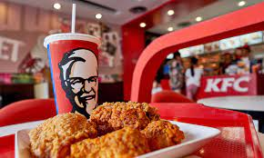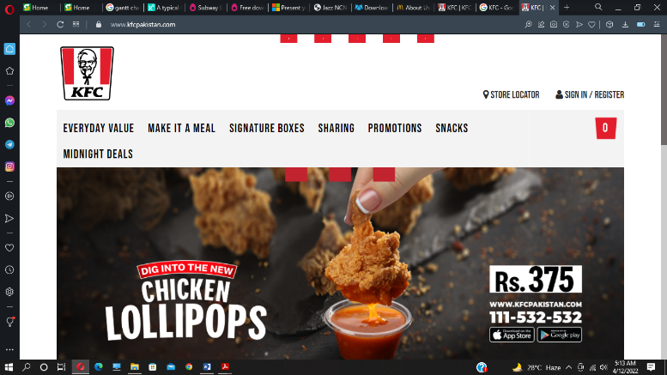

**2.MacDonald:**

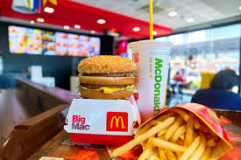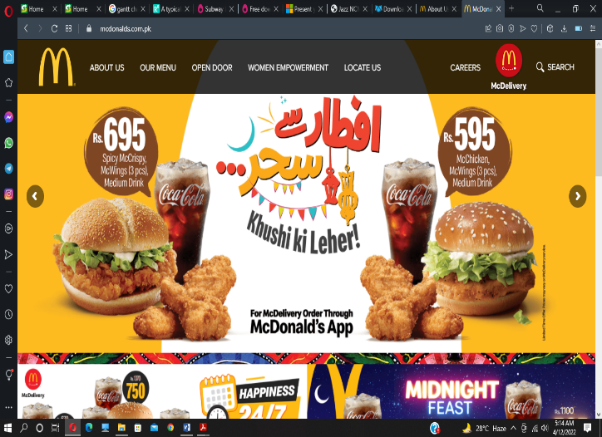At first MacDonald[ref] was just a small shop in 1954, but now it has become the world’s First largest fast food chain brand, it is famous due to its hamburgers. The taste of their hamburgers is recorded to be on the top of taste list, according to customer’s feedback.

**3.StarBucks:**

Starbucks[ref] is an American[ref] multinational chain of coffee house. But unfortunately, there is no branches of Starbucks in Pakistan[ref]. Although it is most probably famous due to its coffee with it round table logic.

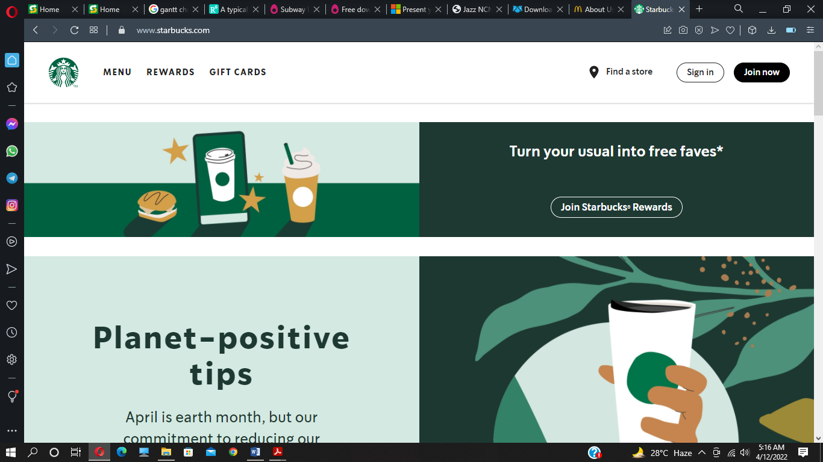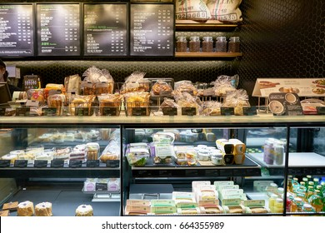

# **Proposed Methodology/System**

We Use Html-5[ref] to write the structural code of this website. By using CSS [ref], we make our website user-friendly and easy to use. We also add references link which help customers to directly go to the desired placed by just click. This task is done with the help of Java-script[ref].

# **Wireframes**

# 8.1 Home Page:

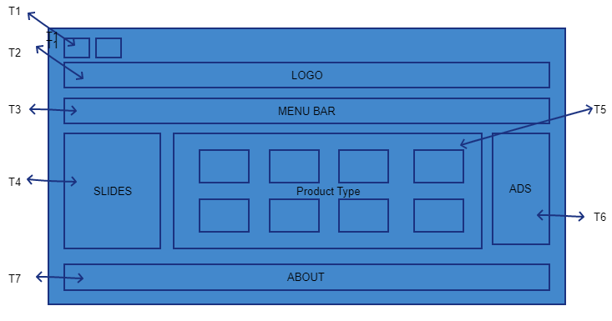

## 

|  |  |  |
| --- | --- | --- |
|  | USER | ADMIN |
| T1 | As a user, I shall be able to access social account of this restaurant | As an admin, I shall able be to give access to the user to move our restaurant social account |
| T2 | As a user, I shall be able to move to the home page | As an admin, I shall be able to change the picture of logo. |
| T3 | As a user, I shall be able to directly move to the specific category | As an admin, I shall be able to add, edit and delete categories |
| T4 | As a user, I shall watch and select or for more information about this add | As an admin, I shall be changing this advertisement due to new products |
| T5 | As a user, I shall choice the product to the specific type for buying | As an admin, I shall update (edit, delete) products |
| T6 | As a user, I shall choice the products which are most popular according to the most visitors | As an admin, I shall be recommended the products whose are most viewed or popular |
| T7 | As a user, I shall be able to see the details of this restaurant | As an admin, I shall be able to edit restaurant details. |

# 8.2 LOGIN-PAGE:

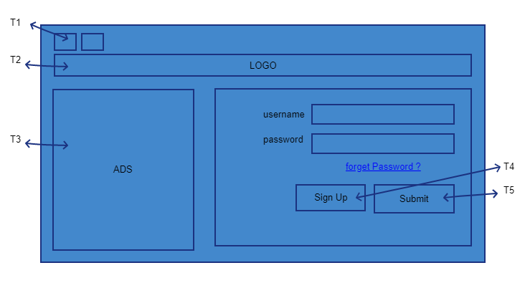

|  |  |  |
| --- | --- | --- |
|  | USER | ADMIN |
| T1 | As a user, I shall be able to jump to social media page of this restaurant. | As an admin, I shall give access to user to jump to respective social media account. |
| T2 | As a user, I shall be able to move to home page of the website. | As an admin, I shall be able to link some other page or change the logo of the website. |
| T3 | As a user, I shall see the products which are most popular according to the most visitors | As an admin, I shall be recommended the products which are most viewed or popular |
| T4 | As a user, I shall be able to create my account. If I don’t have any | As an admin, I shall be given access to the user to create its account. |
| T5 | As a user, I shall after fill the form be able to login my account | As an admin, I shall give access to the user to login through its account |

# 8.3 SIGN-UP-PAGE:

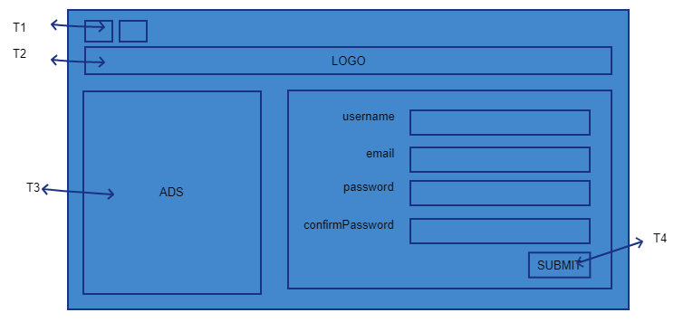

|  |  |  |
| --- | --- | --- |
|  | USER | ADMIN |
| T1 | As a user, I shall be able to jump to social media page of this restaurant. | As an admin, I shall give access to user to jump to respective social media account. |
| T2 | As a user, I shall be able to move to home page of website. | As an admin, I shall be able to change picture of logo. |
| T3 | As a user, I shall see the products which are most popular according to the most visitors | As an admin, I shall be recommended the products which are most viewed or popular |
| T4 | As a user, I shall, after filling the foam, be able to create my account. | As an admin, I shall be given access to the user to create its account. |

# 8.4 DESCIPTION:

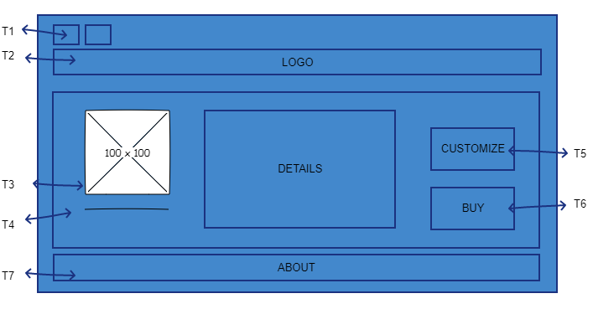

|  |  |  |
| --- | --- | --- |
|  | USER | ADMIN |
| T1 | As a user, I shall be able to jump to social media page of this restaurant. | As an admin, I shall give access to user to jump to respective social media account. |
| T2 | As a user, I shall be able to move to home page of website. | As an admin, I shall be able to change picture of logo. |
| T3 | As a user, I shall be able to see selected eatable. | As an admin, I shall be able to change that particular picture. |
| T4 | As a user, I shall see the description of the selected item. | As an admin, I shall be able to change item’s description |
| T5 | As a user, I shall move to customizing page for the selected item. | As an admin, I shall change the customization page link. |
| T6 | As a user, I shall move to account verification page for buying the selected item. | As an admin, I shall be able to verify the customization and link the user to buying phase. |
| T7 | As a user, I shall be able to see about info of the restaurant. | As an admin, I shall be able to change the about info of the restaurant. |

# 8.5 CUSTOMIZE:

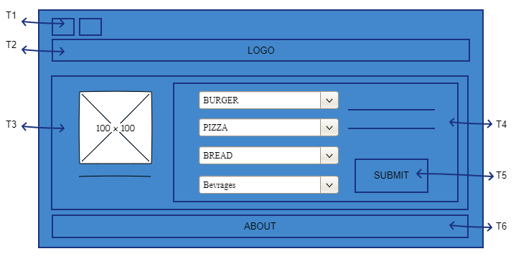

|  |  |  |
| --- | --- | --- |
|  | USER | ADMIN |
| T1 | As a user, I shall be able to jump to social media page of this restaurant. | As an admin, I shall give access to user to jump to respective social media account. |
| T2 | As a user, I shall be able to move to home page of website. | As an admin, I shall be able to change picture of logo. |
| T3 | As a user, I shall see picture of the item and its description. | As an admin, I shall change the picture and description of the item |
| T4 | As a user, I shall be able to customize ( add , remove ) my meal | As an admin, I shall edit the boundaries of customization |
| T5 | As a user, I shall confirm my customization description | As an admin, I shall verify user’s customized description. |
| T6 | As a user, I shall be able to get the info about the restaurant. | As an admin, I shall be able to display about info of the restaurant. |

# 8.6 BUYING PHASE:

|  |  |  |
| --- | --- | --- |
|  | USER | ADMIN |
| T1 | As a user, I shall be able to jump to social media page of this restaurant. | As an admin, I shall give access to user to jump to respective social media account. |
| T2 | As a user, I shall be able to move to home page of website. | As an admin, I shall be able to change picture of logo. |
| T3 | As a user, I shall be able to see final selected item after the customization. | As an admin, I shall display the user its final product. |
| T4 | As a user, I shall enter my account info. | As an admin, I shall look user’s account info. |
| T5 | As a user, I shall be able to submit my account and product info. | As an admin, I shall be able to verify user’s account and product info. |
| T6 | As a user, I shall be able to see the details of product | As an admin, I shall be able to edit the details of the product |

# 8.7 RECEIPT:

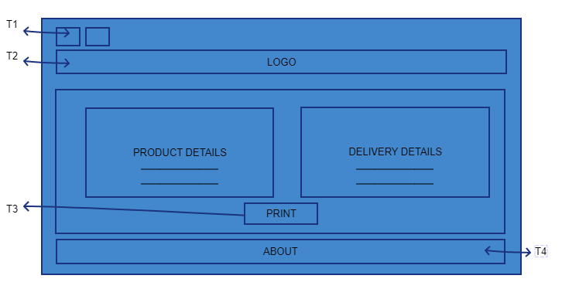

|  |  |  |
| --- | --- | --- |
|  | USER | ADMIN |
| T1 | As a user, I shall be able to jump to social media page of this restaurant. | As an admin, I shall give access to user to jump to respective social media account. |
| T2 | As a user, I shall be able to move to home page of website. | As an admin, I shall be able to change picture of logo |
| T3 | As a user, I shall be able to print receipt. | As an admin, I shall display user receipt . |
| T4 | As a user, I shall be able to see about info of the restaurant. | As an admin, I shall be able change about info of the restaurant. |

# **Timeline/Gantt chart**

|  |  |  |  |  |  |  |
| --- | --- | --- | --- | --- | --- | --- |
| Steps: | First weak | Second week | Third week | Fourth week | Fifth week | Sixth week |
| Abstract |  |  |  |  |  |  |
| Introduction |  |  |  |  |  |  |
| Problem Statement |  |  |  |  |  |  |
| Objective |  |  |  |  |  |  |
| Related works |  |  |  |  |  |  |
| Proposed Methodology |  |  |  |  |  |  |
| Related Work |  |  |  |  |  |  |
| Wireframes |  |  |  |  |  |  |
| Requirements |  |  |  |  |  |  |

# **References**

1. Subway, a customizable fast food restaurant company [Home (subway.com)](https://www.subway.com/en-PK)